**Fundamentals of storytelling**

Welcome! My name is Hadrien and I will be your guide for this course.

**Challenger**

Before we jump in, let me tell you a story. In 1986, the Challenger shuttle's fuel tank ignited and the shuttle crashed, killing the seven astronauts on board.

**Good warning, bad delivery**

The culprits were two redundant seals in a joint that broke. NASA employees warned that flying was unsafe in the following slide (in the circled part), but the message didn't go through. This is an extreme example, but it shows how crucial results can fail to have an impact (or have a bad one) because of bad communication.

**About the course**

Throughout the course, we will learn how to communicate results to different stakeholders using storytelling. We will also cover how to structure a report and build an oral presentation.

**Chapter 1**

We'll translate technical results for non-technical stakeholders, and we'll see how to structure stories to impact the decision making process. And let's be clear right away: data storytelling is not about spinning results, it's about making them stick. For this to work, they should be simple (pruning the message to its core), concrete (can be described or detected by human senses), and credible (can be put to test).

**Data storytelling road**

In any communication strategy, there are several pieces we have to put together to create an effective story.

**Why are stories needed?**

But why are stories needed in the first place? People working with data spend a lot of time collecting and processing data, and modeling and evaluating results.

**Why are stories needed?**

But what about communicating insights? Even the best results could fail to have an impact if the insights are not presented appropriately. One of the main challenges is to convince change-adverse stakeholders that some things should be done differently, especially if these stakeholders are non-technical, and do not feel comfortable with math or statistics.

**What is data storytelling?**

That's why telling stories with data is paramount. So what's data storytelling? It's a powerful mechanism for sharing insights supported by a compelling narrative and efficient visualizations. Why is it so powerful? Anecdotes drive people's imagination and stories are more memorable than metrics, and they add value by giving context to the data. Thanks to that, the audience can understand the insights. So their attention is captured. Those insights facilitate the decision-making process and in turn, drive actions and changes.

1. 1 https://tdwi.org/portals/what-is-data-storytelling-definition.aspx

**Data storytelling**

Let's start with building an effective data story. Two concepts help us build its core. The first concept, the three-minute story, makes us think: if we only had three minutes to tell a story, what would we focus on? The second concept, the big idea, pushes us to state our story's unique point of view in one sentence. These concepts help us articulate our story clearly and concisely.

1. 1 Knaflic, Cole Nussbaumer. Storytelling with Data. Wiley Editorial.

**. Data storytelling**

There are three central elements for any data story: the data, the narrative and the visuals. These elements make the story insightful, as it derives clear learnings from our analysis, explanatory, because we help our audience understand the insights, and concise, giving only concrete and specific facts.

**Data**

To build an effective story, we should include only findings from our models or analysis that apply to the situation. Our story should be based on accurate and reliable data, leaving out all untrustworthy results. More importantly, our story should always include actionable insights: data that drives action.

**Narrative**

A good data story includes a compelling and easy to understand narrative that includes only the key points needed to drive change.

Even though it is tempting to include many disconnected facts, a compelling narrative revolves around one central insight, that takes into account the background and our intended audience so it can clarify the facts for them. Who are they? What do they need to know? Lastly, every data story follows a linear sequence. So every data point builds on each other until the conclusion is reached.

**Visuals**

However, we should be careful not to include misleading graphs.

**Fictional company**

We are going to look at how all the concepts are implemented at a fictional data science consulting company named communicatb.

**Translating technical results**

In the previous lesson we talked about data storytelling.

**Data storytelling**

It captures the audience's attention, provides meaning and context, and helps retain insights, and therefore leads to better-informed decision-making. It also helps persuade change-resistant stakeholders.

**Tech or non-tech approach?**

Now that we learned why designing a story is important, we should look into the next piece: defining how technical our audience is. We will simplify this into technical and non-technical for better understanding, but technical knowledge is a continuum and it's up to you to assess your audience's technical proficiency - the Director of Analytics is likely more technical than the People Ops Generalist. In general, data professionals like to talk about their methods. Less technical audiences however typically just care about what the result is and what the implications are.

**How technical?**

For example, we may need to explain why low accuracy predictions affect the business outcome to supply chain specialists and how better data entry on their end could help. They won't care about our model or hyper-parameter tuning. They will care that if data entry is improved and taken seriously, predictions will be radically better and they will have to deal with a lot less returns and shipping problems.

**Translating technical results into stories**

This requires translating results into easy to understand stories that can engage a non-technical audience. Stakeholders will understand our results, telling stories with simple terms can facilitate decision-making processes and, eventually, drive change. There are different strategies to communicate our insights and results effectively. Let's explore them.

**Awareness**

The first thing is considering our audience. What is their background? What do they know? Understanding our audience helps us adjust our story content to each stakeholder. So instead of explaining how our model works, they should understand the impact and limitations of our predictions. How much do they need to understand to meet our goal? We should explain the results with enthusiasm and be aware of any questions they have. Explaining why we chose the variables to predict is not useful for a non-tech person, we should explain the context in which our model works. What information do they need? Our story should help the audience understand what our project is about. Listing the correlation coefficients could be overwhelming, it's better to explain the interaction between customer traits.

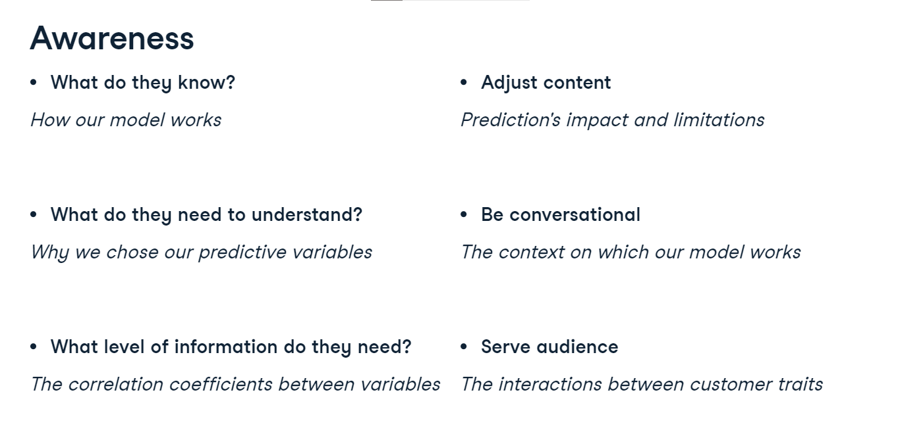

**ADEPT**

The ADEPT technique, as recommended by Kalid Azad, can be pretty handy. We need to use analogies, so the audience can relate new things they are not very comfortable with to other things they understand well already. We also need diagrams, to help visualize. The illustrative power of examples is always efficient.

**Analogies**

As an example, instead of explaining how a neural network works with forward and backward propagation, we can say it learns like a child does, by getting feedback on what is right or wrong, what works and what doesn't.

1. 1 Alpha, "Liam is an expert on the shape sorter", Creative Commons

**Technical jargon**

We also need to pay attention to our choice of word. Acronyms, for example, should be used with caution. They help communication if everyone understands them, but hurt it otherwise. At Space X for example, acronyms have to be approved by Musk. It's good practice to introduce an acronym's meaning the first time it's used. Similarly, we should limit the use of jargon. and instead translate the terminology into simpler and familiar terms. Including a reference guide or definitions in our report is good practice as well. Again, we should take our audience into account: the data manager might now what EDA means, but the HR specialist might not.

**Focus on impact**

Even if we are interested in showing the technical details, a persuasive story usually focuses on impact rather than process. If we are talking about adopting a new technology, we should focus on the impact that technology has on the technical team's time and deliverables. Or if we are explaining how our model predicts an outcome, we should focus on the benefits, such as financial benefits.

**Humility**

Lastly, we should be aware that not all technical details can be removed. In that case, we should make our audience comfortable demonstrating receptiveness to questions, proactively asking if it's clear or if there are any questions after an explanation, and be prepared to explaining concepts again using different strategies.

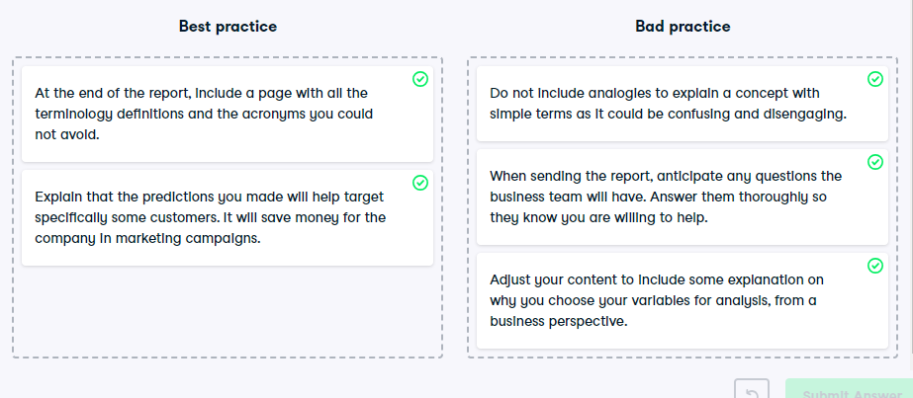

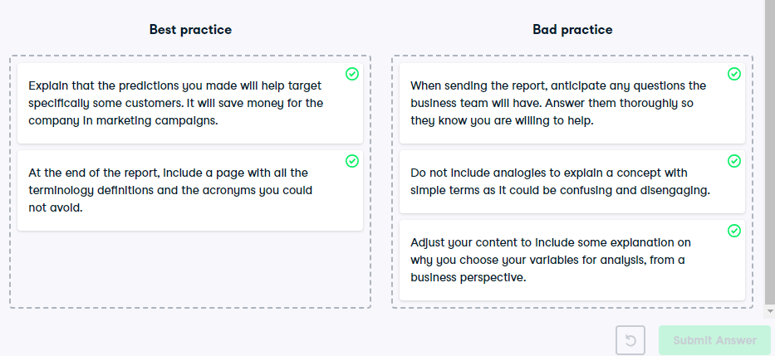

**Impacting the decision-making process**

Well done! We've discussed data storytelling and translating results for non-technical stakeholders.

**Data storytelling**

Particularly, we mentioned that a strong data story has three elements: the data, the narrative, and the visuals.

**Compelling narrative**

Let's focus on the narrative. After we've found relevant insights in our data, we have to find a meaningful way to present them to our target audience, using a narrative that includes only key points and helps us drive change. In other words, we need a compelling narrative or a description of connected events that organizes information to engage the audience and make them care for the results or information shared.

**Narrative structure**

This might sound challenging at first, but following a narrative structure will help. There are several narrative structures that are out of the scope of this course, but it all comes down to a structural framework guiding how we present our story. Imagine that as part of the job at communicatb, we are presenting results to a food company. To start our data story, we should mention the background: details about what problem motivated the analysis, what changed in the previous situation that warranted an analysis, and who the analysis is focusing on. Are we analyzing data from customers? From employees? Or something else?. In our case, we mention that opposite to management expectations the company's total profits have decreased in the last three quarters.

1. 1 Dykes, Brent. Effective Data Storytelling. Wiley.

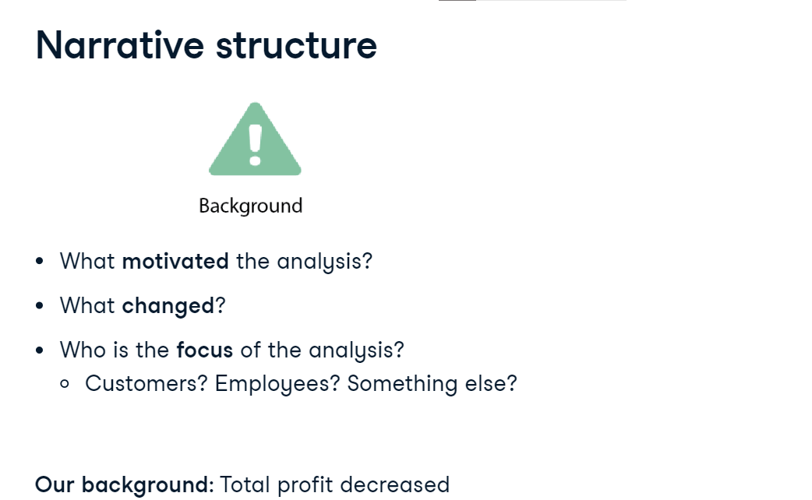

**Narrative structure**

After the problem was introduced, we should provide evidence of the factors that contributed to the problem. But we should only include relevant information and not detailed data that can overload the audience. We analyzed the data and found that the chips sales have increased by 20%. However, sweet item sales have declined overall by 30%.

1. 1 Dykes, Brent. Effective Data Storytelling. Wiley.

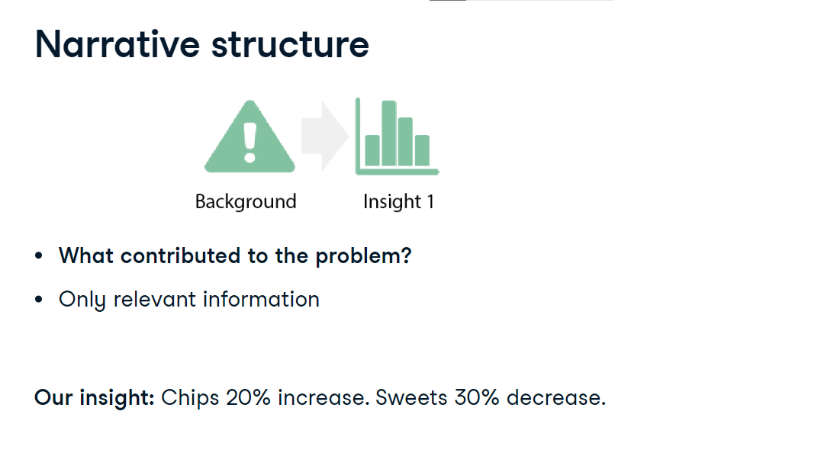

We can also provide more supporting evidence and data, as long as it helps explain on a deeper level the cause of the problem. So after taking a deeper look, we saw that the company's most popular chocolate has seen its sales decreased by 50%.

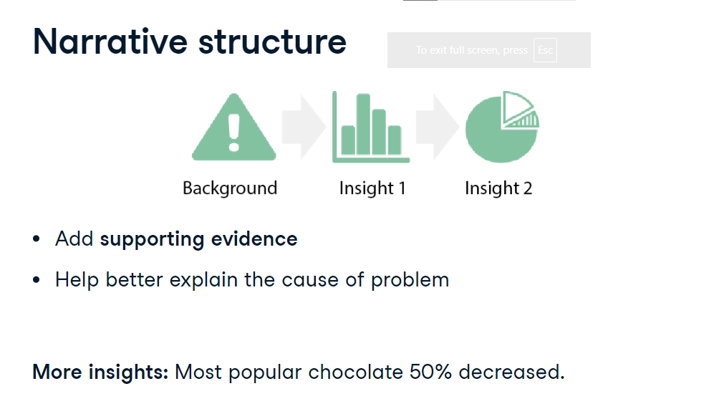

1. 1 Dykes, Brent. Effective Data Storytelling. Wiley.

**Narrative structure**

All the evidence should lead to the climax: the moment when we introduce the central finding of our analysis. It should state clearly what could happen if nothing changes. We predicted that if the company does not make a decision, it will lose 10 million dollars next year.

1. 1 Dykes, Brent. Effective Data Storytelling. Wiley.

**Narrative structure**

After the main finding is revealed, we should finish exploring potential solutions and opportunities, by recommending a course of action to take. We need to be proactive and guide the audience through understanding what to do with our results if we want to impact the decision making process. So according to our predictions, rebranding the chocolate and offering special discounts can achieve a 20% profit. With these steps, we created a narrative that will catch our audience's interest, and is easy to follow.

1. 1 Dykes, Brent. Effective Data Storytelling. Wiley.

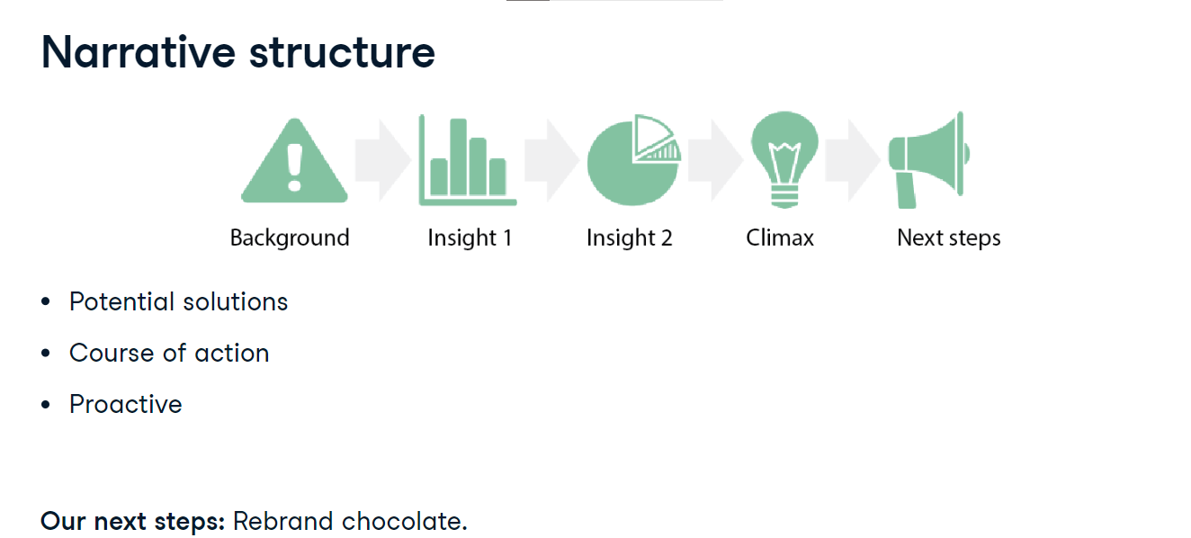

**Building narrative**

Running an analysis, there are several things you might look at, which will in turn drive our narrative. We can explore how a feature changes over time or the time cycle patterns, for example, how chocolate sales are lower in summer but higher in winter. we could focus on how two things are related to each other, for example chocolate price and the customer rating, or display similarities and differences between chocolate consumption between adults and children. Also, we can find groups in the data, such as high chocolate and high coffee consumers vs low chocolate and low coffee consumers. As we craft our narrative, we need to make sure that these data points make a relevant and relatable story.

